TRƯỜNG ĐẠI HỌC HÀ NỘI
Cán bộ coi thi 1: ____________________
Cán bộ coi thi 2: ____________________
TRUNG TÂM ĐÀO TẠO TỪ XA
_____________

BÀI THI KẾT THÚC HỌC PHẦN THỰC HÀNH TIẾNG A2
VIẾT, CA THI: 03 KỲ THI NGÀY 25.05.2025
Hình thức đào tạo: Từ xa - Thời gian: 30 phút. Bài thi có 04 trang.
Thí sinh KHÔNG được dùng tài liệu.

Họ và tên thí sinh: …………………………………Giới tính:………… Số BD:….....
Ngày sinh: ..………………….Lớp:…..………….Mã sinh viên……………………...
Số phách:
✂
Số phách:
Cán bộ chấm thi 1: __________________________
Cán bộ chấm thi 2: __________________________

Part 1 (3 points) Answer the following questions, using your own ideas:

- Why do many people enjoy shopping online instead of going to physical stores?
__________________________________________________________________________________________________________________________________________
- Should students have the right to choose the subjects they want to study at school?
__________________________________________________________________________________________________________________________________________
- Do you think the use of smartphones has affected interpersonal communication?
__________________________________________________________________________________________________________________________________________
Part 2 (7 points) Write one paragraph (about 150 words) about ONE of the following topics
1. Some people believe that success in life depends more on hard work than on talent. Do you agree or disagree?
2. Many young people today want to become famous through social media. Do you think this is a good goal to have? Why or why not?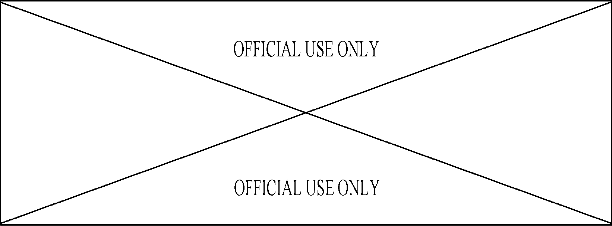
..................................................................................................................................................
..................................................................................................................................................
..................................................................................................................................................
..................................................................................................................................................
..................................................................................................................................................
..................................................................................................................................................
..................................................................................................................................................
..................................................................................................................................................
..................................................................................................................................................
..................................................................................................................................................
..................................................................................................................................................
..................................................................................................................................................
..................................................................................................................................................
..................................................................................................................................................
..................................................................................................................................................
..................................................................................................................................................
..................................................................................................................................................
..................................................................................................................................................
..................................................................................................................................................
..................................................................................................................................................
..................................................................................................................................................
..................................................................................................................................................
..................................................................................................................................................
..................................................................................................................................................
..................................................................................................................................................
..................................................................................................................................................
..................................................................................................................................................
..................................................................................................................................................
..................................................................................................................................................
..................................................................................................................................................
..................................................................................................................................................
..................................................................................................................................................
..................................................................................................................................................
..................................................................................................................................................
..................................................................................................................................................
..................................................................................................................................................
..................................................................................................................................................
..................................................................................................................................................
..................................................................................................................................................
..................................................................................................................................................
..................................................................................................................................................
..................................................................................................................................................
..................................................................................................................................................
..................................................................................................................................................
..................................................................................................................................................
..................................................................................................................................................
..................................................................................................................................................
..................................................................................................................................................
..................................................................................................................................................
..................................................................................................................................................
..................................................................................................................................................
..................................................................................................................................................
..................................................................................................................................................
..................................................................................................................................................
..................................................................................................................................................
..................................................................................................................................................
..................................................................................................................................................
..................................................................................................................................................
..................................................................................................................................................
..................................................................................................................................................
..................................................................................................................................................
..................................................................................................................................................
..................................................................................................................................................
..................................................................................................................................................
..................................................................................................................................................
..................................................................................................................................................
..................................................................................................................................................
..................................................................................................................................................
..................................................................................................................................................
..................................................................................................................................................
..................................................................................................................................................
..................................................................................................................................................
..................................................................................................................................................
..................................................................................................................................................
..................................................................................................................................................
..................................................................................................................................................
..................................................................................................................................................
..................................................................................................................................................
..................................................................................................................................................
..................................................................................................................................................
..................................................................................................................................................
..................................................................................................................................................
..................................................................................................................................................
..................................................................................................................................................
..................................................................................................................................................
..................................................................................................................................................
..................................................................................................................................................
..................................................................................................................................................
..................................................................................................................................................
..................................................................................................................................................

THE END

